**Lab – 36: How to create a group in Intune?**

**Objective:** The objective of this lab is –

* To create a group in Intune.

Groups are used to manage users, and control your employees' access to your organization resources. Microsoft Intune uses Azure Active Directory to manage access to organization resources. This access is controlled using roles in the directory. Intune then manages this access for mobile devices, which allows members of that group to access resources. So, in this lab we are going to create a group of members in Intune.

**Prerequisite:** EMS Enterprise Mobility + Security E5.

**Steps:**

1. Sign in to your Azure Portal, by using the link - **https://portal.azure.com/**. Enter your credentials and click Sign In.

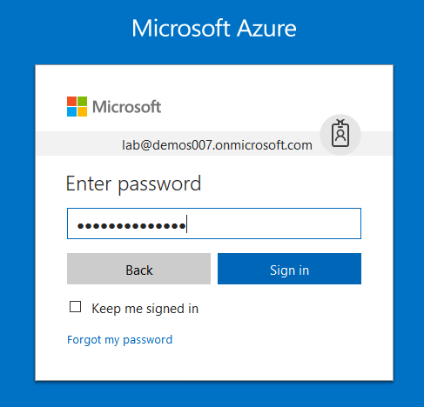

1. Microsoft Azure AD Dashboard will open.

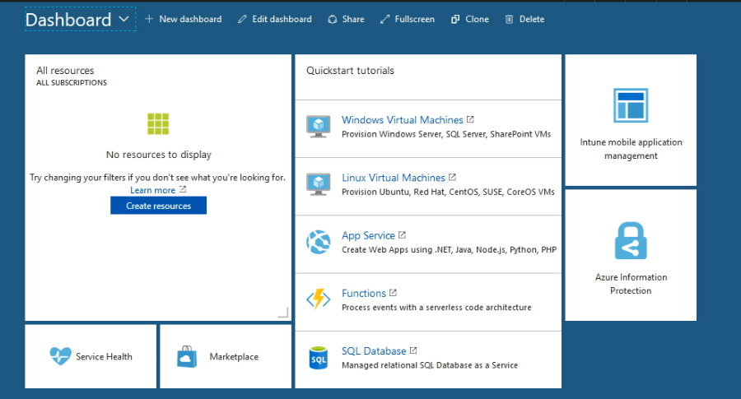

1. Open Microsoft Intune service from the left-hand side of the Azure portal.
2. Once you've opened the **Microsoft Intune** blade, select **Groups**.
3. On the **Users and groups – All groups** blade, select the **+** **New group** option.

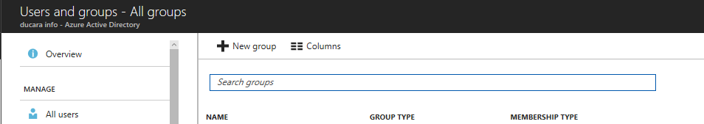

1. On the **Group** blade, enter a **Name** and **Description** for the group.

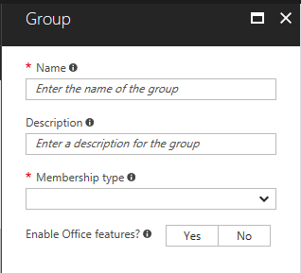

1. Select the **Membership type**. Here we have 3 options- Assigned, Dynamic Device and Dynamic User. Choose if the group will have dynamic or static membership. Here select **Assigned** for the static membership. Do not **Enable Office features** for the test group.

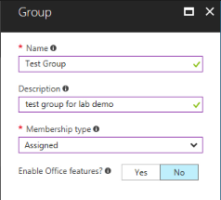

1. Now select members, from the **Members** option. Check the option near the user name to select that user. You can select more than one user. Then click **Select**.

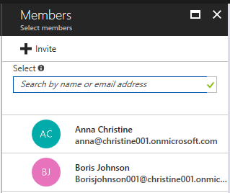

1. Now, you can see the Members section will show the number of selected users.



1. Click **Create** in the Group blade.
2. A confirmation message will pop-up at the top right corner.



1. If you've successfully created a group, it should appear in the list of **All groups**.
2. So, in this way you can create a group in Intune.